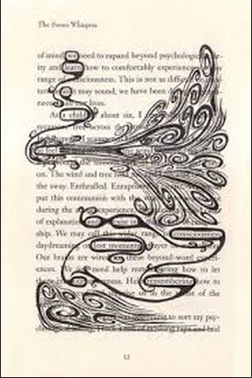
Redacted Poetry and
Photography Assignment

Mrs. L. Kampmeyer Jaeggi
ArTES Magnet
English Language Arts
lkjaeggi@me.com
www.mrsjaeggi.weebly.com
(661) 513-3068

As the final project for this unit, you will be creating a two-part assignment that demonstrates your understanding for one of the major themes from the text. Each part of the assignment will focus on the same theme, which you will have selected based on the discussions we have had in class. While you do not need to be an artist, you will need to use your creativity and imagination to be successful for this project.

The two components are as follows:
- AFTER selecting one theme from the text, you will take a photograph using either your phone or iPad that you believe demonstrates the elements of that theme. Keep in mind that the enhancements of the photograph (color or black/white, altering the exposure or color quality) will contribute to you conveying the idea of your theme. For example, if you theme was “hope”, a black and white picture of a lonely child crying does not convey that idea. Your photograph will need to be AT LEAST the size of a half sheet of paper (4.25 X 5.5), but no larger than a full page (8.5 X 11). You will need to print this page, as it will be mounted with the other component of your project.

- AFTER selecting your theme, you will select one page from the text. Copy the page, and then paste the page into a MSWord or Pages document. Consider manipulating the font size, the margins, and the spacing, but DO NOT change the order of the words or lines, and do not leave anything out of the copy/paste before you print. On your printed page, you will then eliminate all the words that DO NOT address your chosen topic or theme. The words that are left after your redaction becomes your poem. There isn’t a limit to how many words you eliminate, nor is there a limit to how many words are left. Your redaction is a part of the art – it may be as simple as using a black marker to cross out the unneeded text, a pair of scissors cutting out words or lines that don’t belong, or drawing a design or piece of art that covers the words that don’t belong. Keep in mind, however, that your redaction is a part of demonstrating your understanding of theme. A drawing of a sun (which covers the words you intend to eliminate) doesn’t convey the idea of depression, if that’s the theme you were focusing on.

Both elements will be mounted together and will include an artist’s statement, so you must be prepared to discuss and justify each element of your project and how it pertains to your overall topic.

