Oprah Winfrey – Talk Show Host, Actress, Producer, Philanthropist, Media Proprietor  1.  2.  3.  4.  5. | 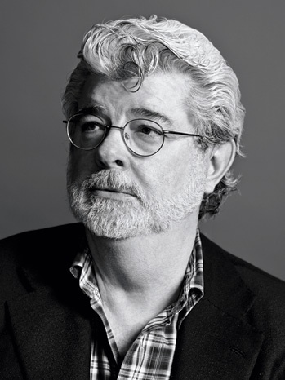  George Lucas – Film director (best known for Star Wars)  1.  2.  3.  4.  5.
Pharmacist  1.  2.  3.  4.  5. | Accountant  1.  2.  3.  4.  5.

Graphic Designer  1.  2.  3.  4.  5. | Substance Abuse Counselor  1.  2.  3.  4.  5.
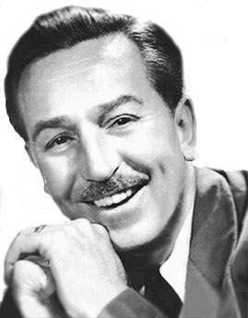  Walt Disney  1.  2.  3.  4.  5. | Cristiano Ronaldo  1.  2.  3.  4.  5.

